**FNC EMadbatah Application**

**Deployment Guide.**

1. Pre-requisites:
2. SQL Server 2005 or higher installed
3. IIS 7 Installed and running (full install)
4. ASP.Net 4.0 installed IIS <http://www.microsoft.com/download/en/details.aspx?id=17718>
5. Data connectivity components (64bit)

<http://www.microsoft.com/download/en/details.aspx?id=13255>

1. Microsoft Office Word 2007 Enterprise.
2. After office Install hotfix <http://go.microsoft.com/?linkid=9706290>
3. 2007 Microsoft Office Add-in: Microsoft Save as PDF or XPS <http://www.microsoft.com/download/en/details.aspx?id=7>
4. Install BullZip PDF Printer <http://www.bullzip.com/products/pdf/download.php>
5. Run the .bat and the .reg file for registry configuration for bullzip
6. Install Open XML SDK <http://www.microsoft.com/download/en/details.aspx?id=5124>
7. Project Package:
   1. Zip file : **EmadbatahWeb.zip** (e-Madbatah website contents)
   2. Zip file : **EPServiceWeb.zip** (e-Parliament Service website contents)
   3. Zip file : **CreateEadbatahDBScript.zip** (script for creating the App database)
   4. Zip file : **EMadbatahAppSrc.zip** (source code of the application VS2010 solution)
   5. Word file **EMadbatah- Deployment-Guide.docx** (deployment instructions)
   6. Bullzip configuration folder (contain .bat and .reg files)
8. Database.
9. Login to the database server instance that will hold the App database
10. Open the script file create-madbatah-db.sql and change the FILENAME Values (in **Bold**) to be suitable with your environment. Or just create this path “**C:\Databases\EMadbatah\”**.

NAME = N'EMadbatah2', FILENAME = **N'C:\Databases\EMadbatah\**EMadbatah2.mdf' , ….

NAME = N'EMadbatah2_log', FILENAME = N'**C:\Databases\EMadbatah\**EMadbatah2_log.ldf' ….

1. Run the script create-madbatah-db.sql. (this acript
2. Wait for the script to finish execution.
3. The database is ready. You can do fast check to see if it is exist and the login emadbatahuser exist.
4. IIS.
   1. Make sure IIS is installed and running.
   2. ASP.NET Registration:
      1. Open your command prompt (Windows + R) and type cmd and press ENTER  
         You may need to start this as an administrator if you have UAC enabled.  
         To do so, locate the exe (usually you can start typing with Start Menu open), right click and select "Run as Administrator"
      2. Type cd C:\Windows\Microsoft.NET\Framework\v4.0.30319\ and press ENTER.
      3. Type aspnet_regiis.exe -ir and press ENTER again.
      4. At this point you will see it begin working on installing .NET's framework in to IIS for you
      5. Close the DOS prompt
   3. Enable ASP.NET 4.0 in IIS
      1. Open IIS Manager
      2. Open ISAPI and CGI Restrictions

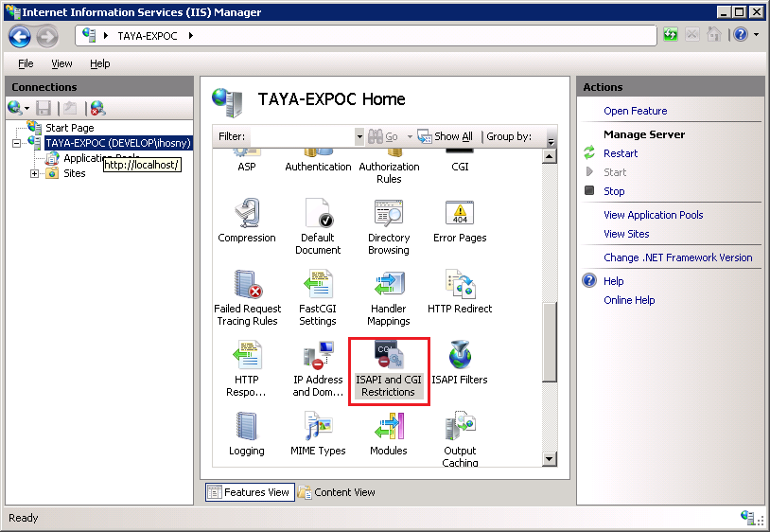

* + 1. Allow ASP.NET 4

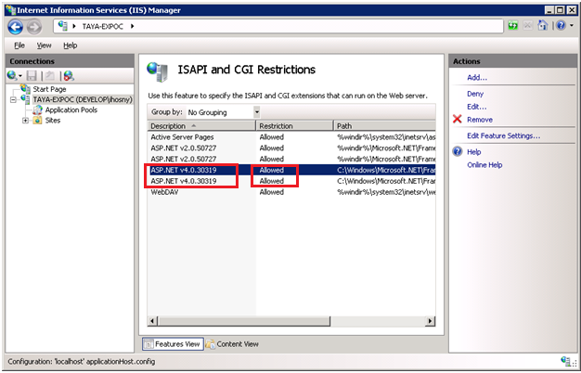

* + 1. Security Configuration
       1. Select Website from left panel
       2. Open .NET Authorization rules
       3. Remove the deny rule of anonymous users as per the below screen

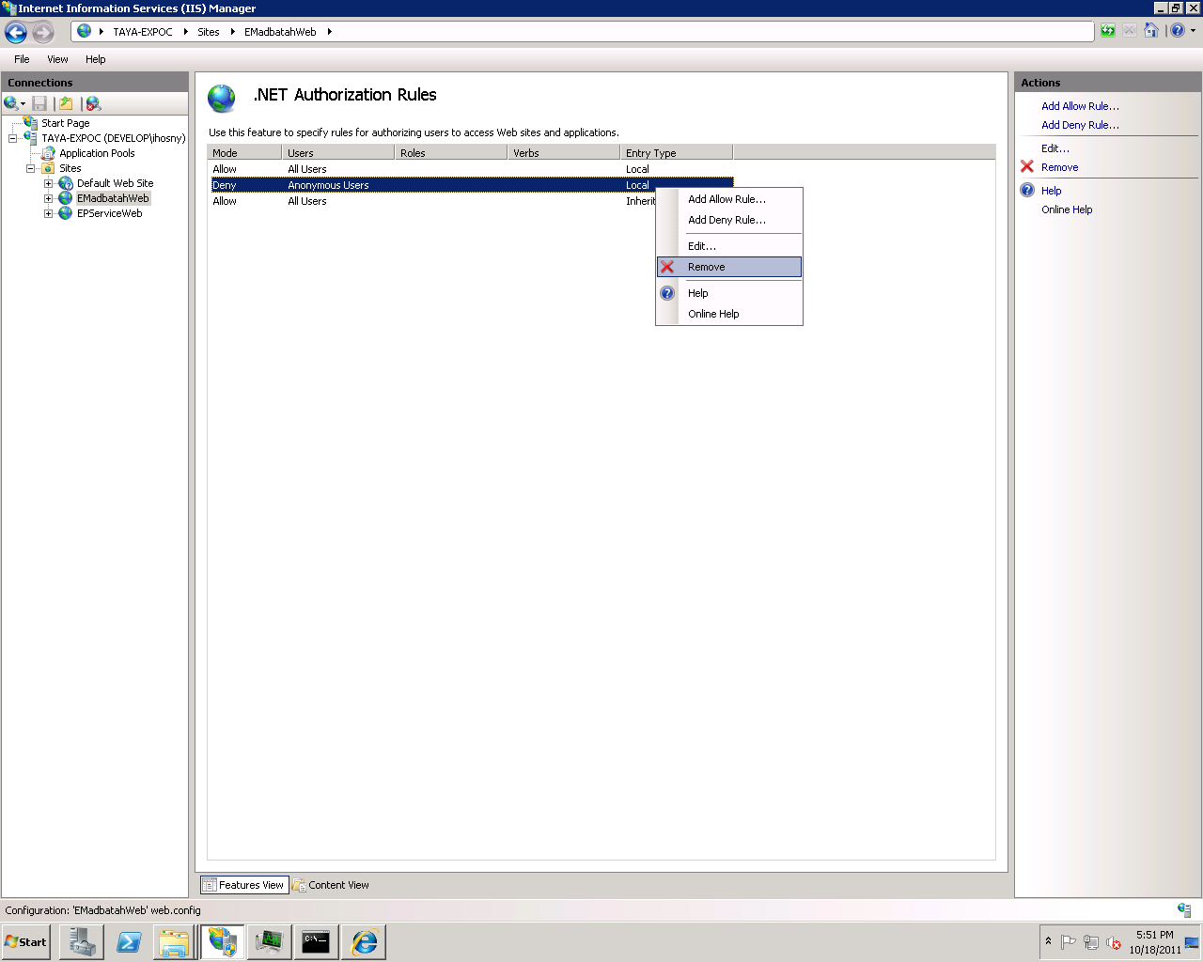

* + 1. Enable Windows Authentication
       1. Open IIS Manager.
       2. In **Features View**, double-click **Authentication**.
       3. On the **Authentication** page, select **Windows Authentication**.
       4. In the **Actions** pane, click **Enable** to use Windows authentication.

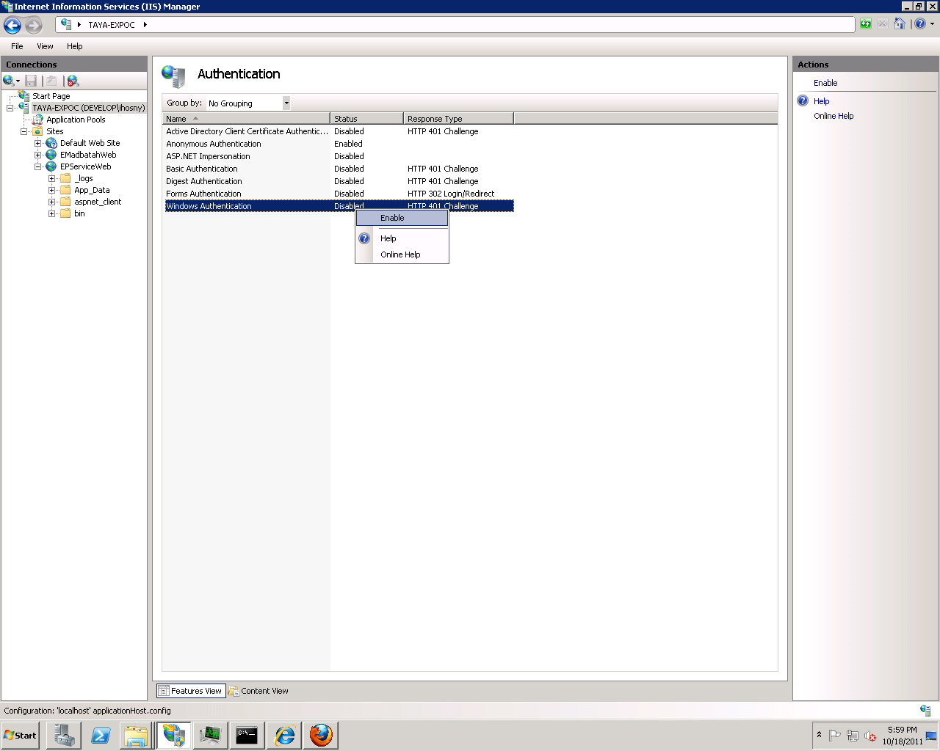

* 1. Create 2 folders in the path C:\Websites (or another suitable path)

C:\Websites\EMadbatahWeb to hold app main website

C:\Websites\EPServiceWeb to hold E-Parliament web service

Note: Then copy each website content from its corresponding zip file.

* 1. Give full control permission to NetworkService on the 2 folders
  2. Create Website for the E-Madbatah App as shown in the following screens:
     1. Open IIS Manager
     2. Right Click on sites and choose “Add Web Site…”
     3. Configure EMadbatahWeb website as shown below:



* + 1. Create another website for the EP service and configure as shown below:



1. Application pool configuration
   1. Expand the left-hand side (Services and Applications) and select **Internet Information Services**
   2. You'll now have a new applet within the content window exclusively for IIS.
   3. Expand out your computer and locate the **Application Pools** node, and select it. (You should now see *ASP.NET v4.0* listed)
   4. Expand out your **Sites** node and locate the site you want to modify (select it)
   5. To the right you'll notice **Advanced Settings...** just below the *Edit Site* text. Click this, and a new window should appear
   6. Select the .NET framework version to v4.0
   7. Select Managed pipeline mode to Classic
   8. Select Identity to NetworkService
   9. click ok.

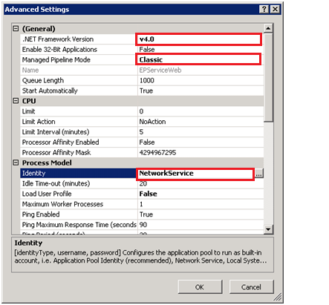

1. Website Configuration:
   1. **Web.Config**

Under the <connectionStrings> section change the IP part for the database connection string

**EMadbatahEntities**: change the Data Source to match the IP of the machine holding the database.

And change:

For ADConnectionString change the connectionString to match your Active Directory Configuration.

In MyADMembershipProvider under membership section

For connectionUsername put valid AD user

For connectionPassword put password for that user

* 1. Under the **App_Data** folder file **AppSettings.xml**

Set the following values:

* + 1. VecSysServerPath : the path of the root folder containing all sessions folders.
    2. AudioServerPath : the path of the root folder containing all Audio folders of all sessions.
    3. EParlimrntWebServiceURL : If Service is deployed on another machine set new URL.
    4. AllowedDomainName : name of the Active directory domain (if user name is Develop\unada, then here we put Develop).
    5. In the DefaultAdmin section put the Main Admin Info
    6. Under the EmailServer section Email Server Details for the notification emails work properly

1. First Run:
   1. Start the website by opening it in the browser.
   2. You are currently Admin. You can open System Admin page -> then to Users Management. Add Users and assign their roles, and info.